**DAILY ONLINE ACTIVITIES SUMMARY**

|  |  |  |  |  |  |  |  |  |
| --- | --- | --- | --- | --- | --- | --- | --- | --- |
| **Date:** | **31/05/2020** | | | | | **Name:** | **V ANJANA PAI** | |
| **Sem & Sec** | **IV sem & B section** | | | | | **USN:** | **4AL18CS094** | |
| **Online Test Summary** | | | | | | | | |
| **Subject** | | **-** | | | | | | |
| **Max. Marks** | | **30** | | **Score** | | | **-** | |
| **Certification Course Summary** | | | | | | | | |
| **Course** | **Introduction to Digital Marketing** | | | | | | | |
| **Certificate Provider** | | | **Great learning academy** | | **Duration** | | | **2.5 hours** |
| **Coding Challenges** | | | | | | | | |
| **Problem Statement1:** Write a Java program to calculate npr. | | | | | | | | |
| **Status: Executed** | | | | | | | | |
| **Uploaded the report in GitHub** | | | | | **YES** | | | |
| **If yes Repository name** | | | | | **lockdown-coding** | | | |
| **Uploaded the report in slack** | | | | | **YES** | | | |

Online Test Summary: No internals conducted today.

Online Certification Course Summary: In today’s session I learnt about Adset Set up guide, what is custom audience and about the Types of ads from the Digital Marketing Course. And also completed the course by attending the quiz.

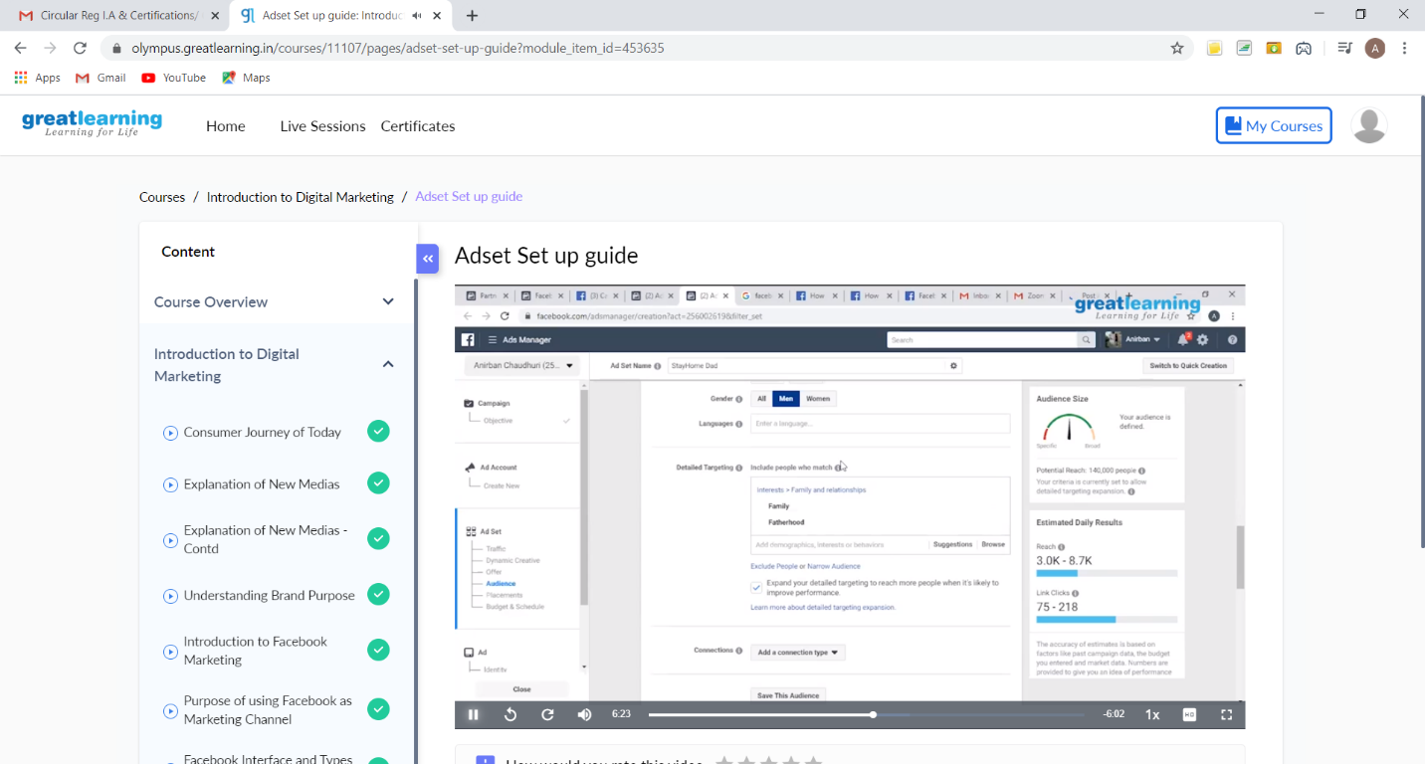

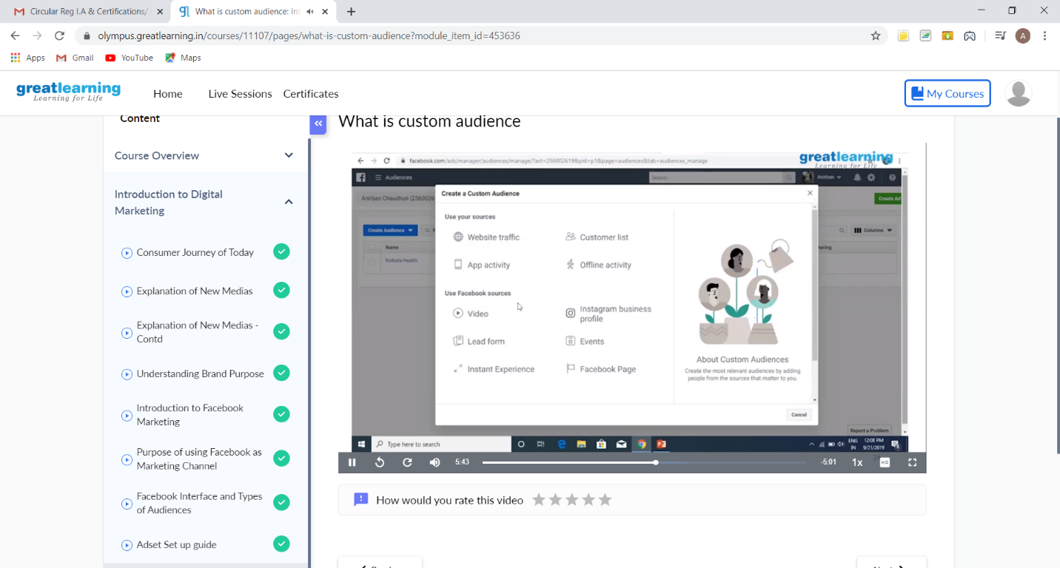

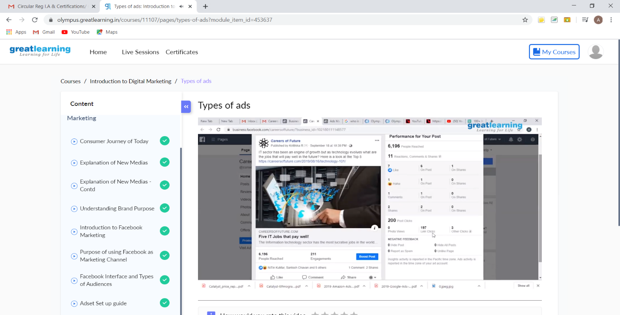

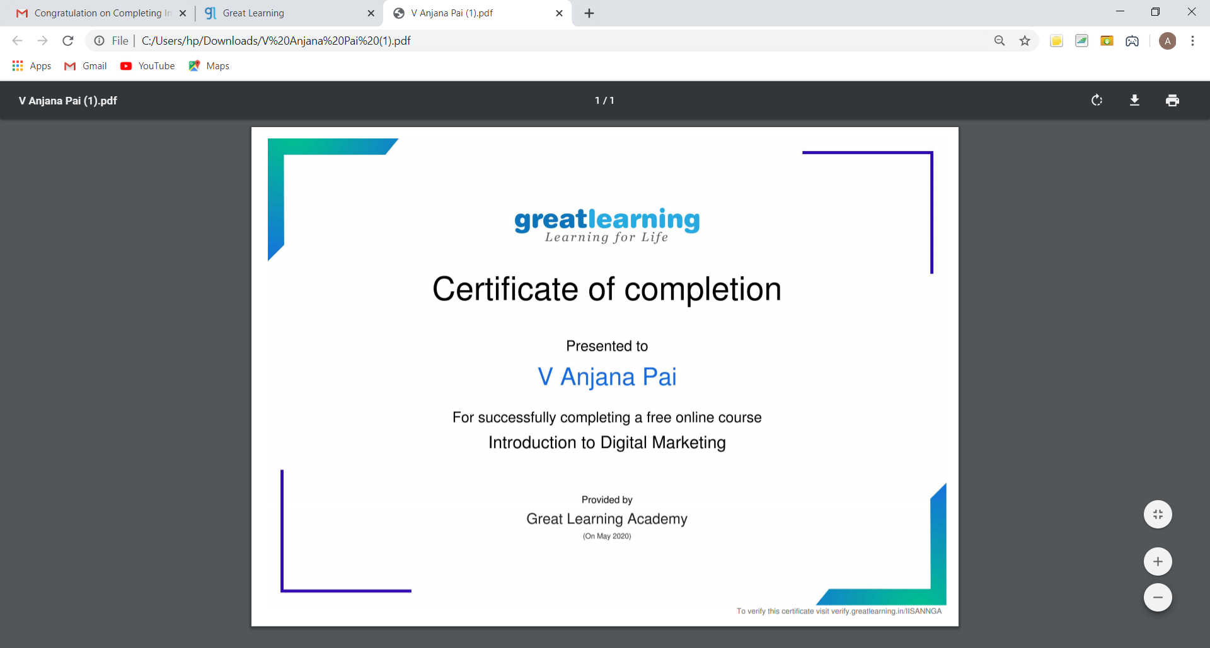

These are the Snap shots of today’s sessions and the Certification of Completion of the course.

Online Coding Summary: **Today I had received one program from prof. Shilpa CSE Dept. The program is mentioned above in the coding challenges(pg.01). I have also uploaded it to my GitHub repository.**

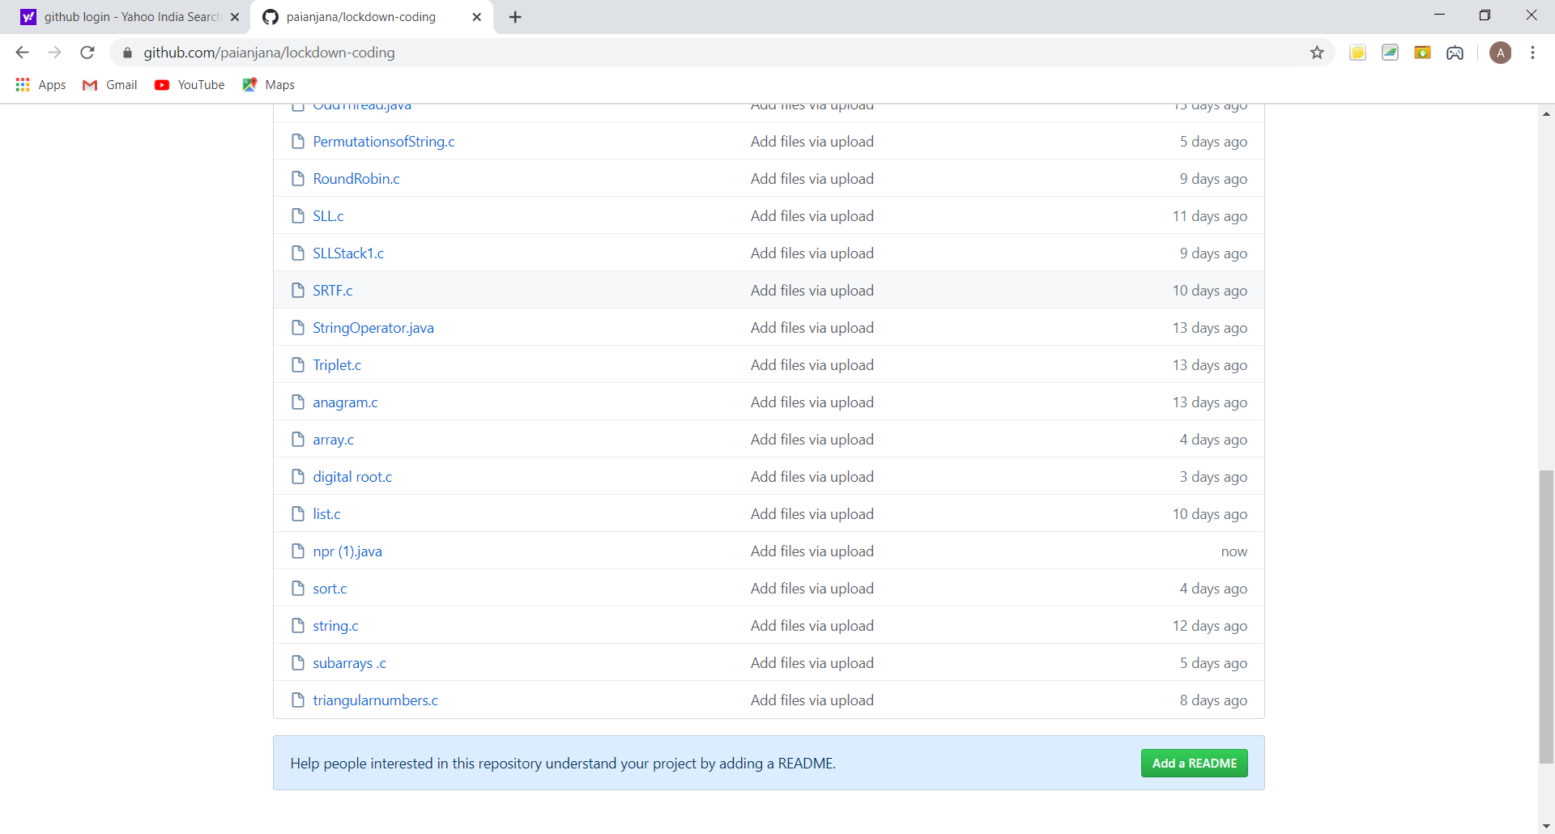

**This is the snap shot of my GitHub repository** where I have uploaded the code. File name is npr(1).java